Table of Contents
Go to the Krishna.org website using this URL which will take you directly to the page with the download links 2
You need to first Download the following 2 Zip Files: 2
History of Veda Base 3
What is the VedaBase? 3
History — The MS-DOS VedaBase 3
MS-DOS VedaBase 5
The Windows VedaBase 6
Expanding VedaBase to Include Prabhupada Disciples 6
The Original Prabhupada Books VedaBase 7
How to Install the Windows Original Books VedaBase on your Computer 8

Go to the Krishna.org website using this URL which will take you directly to the page with the download links
https://krishna.org/installing-original-books-prabhupada-vedabase-on-your-computer/
You will have to download 2 zip files. You can do that on from the website page or you can use the following URL’s and do it from here (after you have downloaded one or both of the two formats of this document, MS-Word or PDF), and then go to the Heading with title “How to Install the Windows Original Books VedaBase on your Computer” BELOW on Page 8-11. (See Table of Contents)
Suggest that you printout this document from page 8-11, because when you start the install, you will not be able to see the Windows Browser nor the website site page, because the install, works outside of the windows and takes over the whole screen environment; hence you can refer to the printout for the instructions on how to install.

You need to first Download the following 2 Zip Files:
Original Books VedaBase
VedabaseFonts

History of Veda Base

What is the VedaBase?
Older devotees will remember the “VedaBase”. VedaBase, a computer database of the books, letters and audio transcripts of His Divine Grace A.C. Bhaktivedanta Swami Prabhupada was released by Bhaktivedanta Archives originally in the 1990s.
Previously, before the VedaBase, if one wanted to find Prabhupada quotes on a particular subject that was quite difficult. One would need to read through all of Prabhupada’s books and letters and conversations and compile the quotes in that way.
However, once the Prabhupada VedaBase was released devotees could just type in their search queries and immediately get a list of Prabhupada quotes relevant to their keywords.
This was truly a revolution, empowering devotees to quickly search for and find all the relevant quotations from Prabhupada on the topics they wanted to research.

History — The MS-DOS VedaBase
Initially the Prabhupada VedaBase was released as an MS-DOS application using the Folio Views program. Folio Views was developed by the Mormons to store all their church teachings and make them easily accessible to their members. And it turns out that Folio Views was a uniquely perfect application for searching within the teachings of Srila Prabhupada also.
Although we have searched widely, we have never been able to find any other software application that comes close to the power and flexibility of Folio Views for searching within the teachings of Srila Prabhupada.
It takes a little while to get used to how the searching works. It is quite different from a Google search. Folio Views does not really search in documents, it searches in “folios” and for the purpose of the VedaBase folios are generally paragraphs of text.
The default action of a Folio Views search is it returns all the “folios” that contain all the words you type in a search query. So you can type as many words as you need to refine the search results down to a reasonable number.
This is not meant to be an instruction book, how to use it, I will provide a link to that below in the description of the Windows version.
From the beginning Bhaktivedanta Archives, instead of actually providing the original books of Srila Prabhupada, as you would imagine an archive would, they included the most up-to-date unauthorized changed versions of Prabhupada’s books hot off the BBT editors desks. They were publishing such modern versions of Prabhupada’s books in the VedaBase that the versions appearing in the VedaBase had more changes than even the most recently printed BBT books…
Of course, the devotees interested in the original teachings of Srila Prabhupada were not very happy about that so we immediately released an MS-DOS VedaBase containing the original books of Srila Prabhupada, or at least the closest we could get at that time to the original books. If you have a Windows computer you can still run that original MS-DOS program we released in the 1990s:

MS-DOS VedaBase
This is the final version of MS-DOS VedaBase that we released in 1998. After you install it you will find two new applications in your programs list:
- VedaBase
- VedaBase Diac
They are identical except VedaBase has got plain text and VedaBase Diac will display the diacritical characters. It is more practical to use the VedaBase version for searching because searching becomes very difficult with the diacritical version.
It is quite self-explanatory. Basically, you just press the space key to do a search and search window pops up and you start typing words and the result will include all the folios [paragraphs] that contain all the words you have typed. There are more advanced search options, but this is the basic idea: press the space key and type in your search words.

The Windows VedaBase
After Windows was introduced VedaBase was updated to use the Folio Views windows application.

Expanding VedaBase to Include Prabhupada Disciples
Bhaktivedanta Archives expanded the idea of Vedabase. Originally Vedabase was a database of the teachings of Srila Prabhupada but they expanded it to a database of all of Prabhupada’s disciples teachings, and Prabhupada’s teachings all bundled up together.
So now, when you search in the VedaBase, you get so many results, but there is no way to see who is speaking, if the results are from Prabhupada, or the results are from Prabhupada’s disciples…
Our argument was that, “Sure, there may be some benefit in some of these extra books you have added, but please keep it in a separate database.” So, for some time Bhaktivedanta Archives did that, they released a Prabhupada VedaBase and a Disciples VedaBase. But after some time, they decided to merge everything. So, when you do a search in the VedaBase now, you will not get just Prabhupada results, you will get all his disciples results mixed up.

The Original Prabhupada Books VedaBase
So, a need was felt among many of the disciples of Srila Prabhupada to produce a Prabhupada only Windows VedaBase with the original first edition books and teachings of His Divine Grace A.C. Bhaktivedanta Swami Prabhupada.
Madhusudana Prabhu from UK has been working very hard on this over the years and the version of the VedaBase in the download below is his most recent “Original Books VedaBase”.
It has always been a little difficult to install this and generally, these days, devotees are not able to install any version of the Vedabase, even the Bhaktivedanta Archives version, on their computers. So the purpose of this post is to provide you an easy way to get Prabhupada’s Original Books Vedabase running on your computer.

How to Install the Windows Original Books VedaBase on your Computer
VedaBase is a Windows application and it is not very easy these days to install it on Mac computers. The only real way would be to install windows using some sort of virtual machine platform then install Vedabase in Windows on your Mac.
We are using VedaBase 2003 install system so to make it work the Original Books VedaBase has been renamed to:
Bhaktivedanta VedaBase 2003.nfo (this is actually Original Books Vedabase Version 3.)
All you need to do to install it on Windows is download and unzip the following two files:
Original Books VedaBase
VedabaseFonts
If you have any version of Windows VedaBase already installed you need to uninstall it.
If you have got other infobases [.nfo files] you should be able to open them also in this version of Folio Views.
First unzip “Original Books VedaBase” and find the setup.exe file and double-click on it. That will launch the VedaBase Installer:
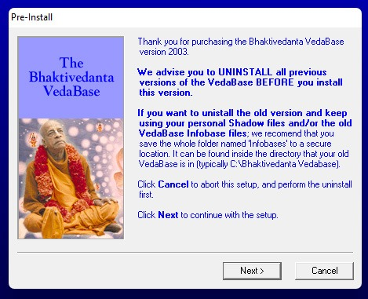
Then you go through the install screens accepting the defaults.
That will install Original Books VedaBase on your computer in the folder:
c:/Bhaktivedanta VedaBase 2003
Then you need to install the VedaBase Fonts. So just unzip that file and open up the fonts in Windows explorer and open the fonts control panel and drag the VedaBase fonts onto it to install them.
Then it is recommended that you restart your computer.
The installed program is called “Bhaktivedanta VedaBase 2003”. So just launch this program: Actually after you install the VedaBase, there will be an Short-Cut Icon on your Desktop that look kind of like this: V
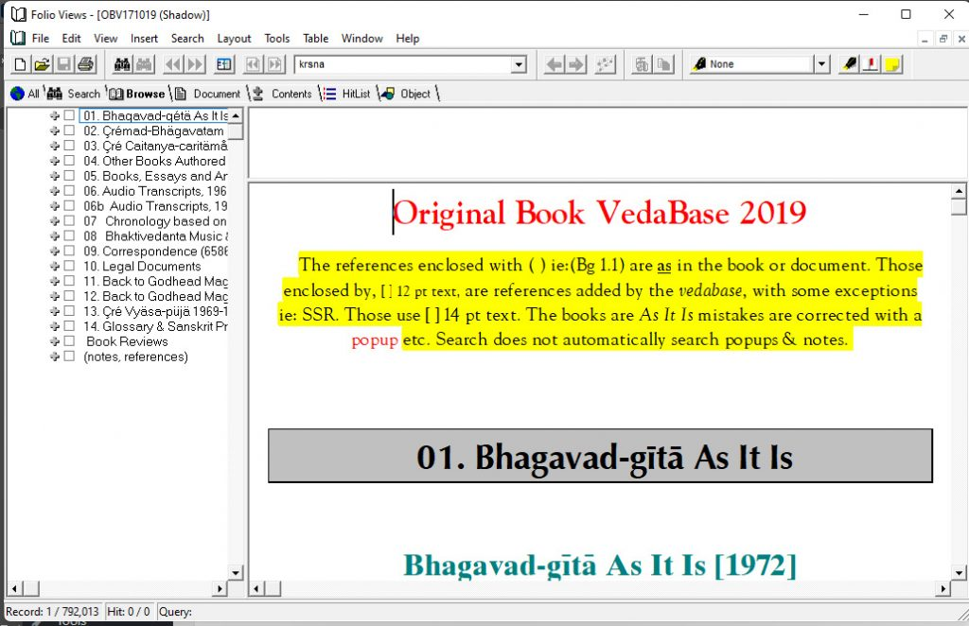
So everything should be displaying correctly as long as you have installed the Vedabase fonts on your computer EXCEPT in the left column the table of contents font is not correct.
To fix this you need to go to Tools > Options and change the Infobase View Font to ScaHelvetica:
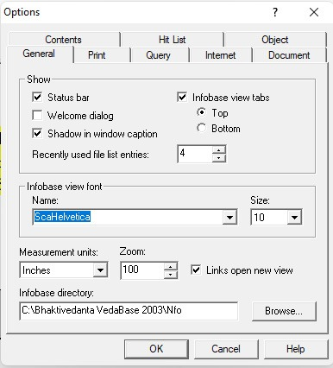
So now everything should be installed and working.
If you have any problems let me know in the comments on this post and we can sort it out.
If you have any problem leave a note in the Comment facility at the end of this Website Contents Page.
In addition, if you want to really want to learn the power of “Advance Search”, please email me at updindia@gmail or we can communicate via WhatsApp my number is +1 424 229 0082 With only a few instruction you will get the idea of how to use it, and it will depend on your imagination of coming up with Phrases or even sentences within Quotes, like:
“Three modes” or “Three gunas” or “Qualification of a guru” or “Who can be guru” or “genuine spiritual master” or “Krishna is merciful”

